Asia-China-Flat Handle Spade Money, Square Foot 方足, H 3.181 R10

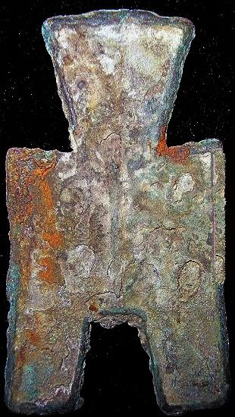 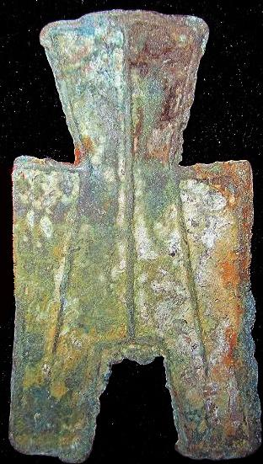

Flat Handle Spade Money, Square Foot yì fāng方足, H 3.181, R10, length 4.3 cm. / 1.69 in.

共邑方足布."共邑", place of the Wei Nation. Some Experts read it Northern Qi (Běi qí 北祁) Coin of Zhao Nation.